**How can Data Strategy & Governance enable AI to drive business value.**

Contents

Section 1: Key components 1

Section 2: Driving Business Value 1

Section 3: Enabling business use cases 1

Section 3: Across key Strategic Digital initiatives 1

Section 5: Building data foundations 1

Section 6: A word of caution 2

Section 7: Taking the first step 2

Authors & Contributors 2

# Section 1: Key components

* 1. Business value drivers i.e. revenue growth
  2. Business use cases i.e. enhancing demand planning & forecasting using AI
  3. Strategic Digital initiatives i.e. Revenue Generation Management
  4. Data foundations i.e. improving data quality

**Pawel Kaczmarek:**

Let me ask you a question—

how can Data Strategy & Governance help AI truly deliver business value?

Gartner reports 79% of executives see AI as critical — yet up to 60% of initiatives could fail by 2027

without strong data governance.

Why?

Because AI is only as strong as the data and structure behind it.

Hello, my name is Pawel Kaczmarek.

I have over 20 years of experience leading complex transformation projects.

Today, I manage the **Cloud and Data Engineering** practice within Cloud and Digital CEE.

Together with my colleagues, I’m here to show you how the right approach to data

can transform

the way your organization operates.

Here’s the foundation:

Effective Data Strategy & Governance provide AI with:

• Trusted, highquality data

• Clear accountability

AND

• Rules for responsible, explainable use

But the foundation alone isn’t enough.

To unlock value, you also need a culture of experimentation.

AI isn’t plugandplay — it’s test - learn - adjust - repeat. Again and AGAIN and again.

Generative models show it clearly: same input, different outputs.

That’s why continuous validation, refinement, and human oversight are essential.

Moreover

Organizations that support safe experimentation — with data sandboxes, crossfunctional teams, and agile governance — discover use cases that MATTER faster.

So, AS your organization is looking to create more value,

this requires that the AI that you’re implementing needs to be aligned with strategy and run on solid data

I know this is a lot to take in, But let me just leave you with one thought:

**Data Strategy & Governance shouldn’t just control** — **they should enable.**

Enable discovery. trust. scale.

Govern for trust. Enable for value. And never stop testing.

----

Data with Direction, AI with purpose, so Business can be done better.

-----

# Section 2: Driving Business Value

* 1. Revenue growth
  2. Cost reduction
  3. Risk mitigation

**Michael Norejko:** When exploring the application of GenAI, and any derivatives of AI, it is important from the outset to identify specific business use cases which demonstrate how GenAI will help to realise business value; whether it is in the form of revenue growth, cost reduction, operational efficiency or risk mitigation. Unless you are in the business of building AI as a service offering it makes very little sense allocating hundreds millions of euros in a technology for the sake of having the first mover advantage in that technology. Interestingly, PwC UK in a recent CIO survey ([PwC](https://www.pwc.co.uk/services/technology/generative-artificial-intelligence/genai-growth-opportunities.html), 2024) have identified that 47% of CIOs are struggling to meet their ROI expectations, which supports our thesis that for GenAI to be successfully adopted and scaled it needs to be *commercially viable* just as much as it needs to be *technically feasible*. Meaning, the business needs to have a thorough understanding of the business value that it can drive and not just focus on how it can be deployed. My name is Michael Norejko, I have 15 years’ experience of supporting digital transformation programmes with a focus on building data & analytics capabilities, and I strongly believe that without a robust business case and solid data foundations any organization looking to adopt GenAI will fail to do so beyond an initial proof of concept. That is a strong point of view, so allow my team and I to elaborate on this further.

# Section 3: Enabling Business Use Cases

* 1. Demand planning & forecasting in Finance using rules based ML

**Paweł Fiderek:**

In the era of LLM boom organizations often forgets about most basic but very effective AI based tools utilizing ML algorithms. Even if some can say that ML is not as advance as modern LLMs or even SLMs, such algorithms can still provide a lot of very usable features and information that can give the organization this edge over other competitors. It is easy to imagine few use cases that can introduce totally new overview for finance institution strategies, portfolio and offered services, such as:

* Client segmentation – that helps to profile marketing strategy to certain group of users, depending on their income, location, job, sex or age
* Credit Risk Modelling
* Fraud detection and prevention
* Financial Forecasting
* Customer Lifetime Value Prediction (CLV)
* Anti-Money Laundering (AML)
* Loan Approval Automation
* Sentiment Analysis for Market Prediction  
  1. Contract Management in Procurement using LLMs
  2. Resource allocation in Supply Chain using Constraint Based Optimisation

**Ernest Orlowski:**

There are many innovative IT technologies hitting the market every year. Data Analytics, RPA, ML, hundreds of cloud services and also Generative AI. It can be overwhelming. Business and IT leaders. are wondering how the technology could improve efficiency of their business or even completely redesign how the business functions.

My name is Ernest Orlowski, for the better part two decades I have been involved in supporting enterprise organisations in their technology journeys – from chosing the right technology, building the business case and ensuring the technology has a real business impact.

They also wonder how to start and bring new technology in their organisation. Gen AI technology consierations are not any different.

Whether it is improving demand planning to reduce obsolete stock in retail -- or providing real-time insights to identify instances of fraud in banking --- the key step is to define business use cases.

Business use cases should articulate how Gen AI will improve effectiveness or solve problems across business processes or business functions. Lastly how this is supporting execution of the business strategy and/or how is it impacting business KPIs

The essential element for me has always been to map the technology to the value it’s delivering and how is it affecting revenues or time to market or any other KPI meaningful to the organisation you are working for.

**Wiktor Witkowski**:

In our latest PwC CEE 2025 Cloud and Digital survey, over 55 percent of C-suite leaders said they plan to use AI not just to cut costs, but also to grow revenue ([PwC CEE](https://www.pwc.pl/en/publikacje/ready-for-artificial-intelligence.html), 2025).

On the cost side, AI is helping take over boring, repetitive tasks. But we’re seeing much bigger results in more complex areas. For example:

* A major insurer improved claims underwriting efficiency by 30 percent
* A large retailer cut product development time by half

But automating manual work is just the beginning. On the revenue side, we’re seeing serious impact too:

* Up to 20 percent increase in sales by combining next-best-action models with better trade promotion management
* Up to 20 percent revenue protection by catching commercial leakages, like missed discounts between invoices, purchase orders, and contracts

I’m Wiktor Witkowski. For over ten years, I’ve helped companies get ready for digital transformation. One thing I’ve seen again and again: if you don’t build on real data and constant feedback, these projects either stall or fail because people don’t adopt them. Today, we’ll look at how to make sure that doesn’t happen.

**Paweł Wrona**

Data…

It’s the fuel that accelerates  business growth and strategic initiatives. Let me share a few insights on key factors which are decisive  in a successful Digital Transformation.

But before that, I’d like to ask you an important question.

Have you ever wondered why so many AI projects fail  ?

It’s because of poor data!

Poor data equals poor outcomes of your AI projects, analytics or reporting. It may be obvious, but how do we fix it? Let me tell you how to get started.

Hello/ Hi , I’m Paweł Wrona and as the leader of Data Mesh Incubator, which gathers  over 100 specialists in the  fields of data management, engineering and architecture, I’ve been helping various international companies in their digital transformations.

Over the years, I’ve learnt how to build a modern data foundation so you can avoid all the traps and start using data for your business goals. Let me share an example.

One of the big banking groups operating in central Europe spent over 2 years developing a new analytical platform and trying to enhance data availability, yet more and more business opportunities were lost.

So, What was the reason?

There was a mismatch between strategic goals and spending resources.

and that caused a lot of waste.

Only after we looked at the project and matched business and technology views, we were able to focus on what is really important and create business value that was missing from the start.

We began with strengthening their data foundation and testing it on selected use cases. Then, We built the first goal-oriented data products,  delivering the change where it’s really needed. Finally, we clarified further steps on the Roadmap, preparing the organization for the next phase.

Mistakes are a natural part of any transformation, but If we know where the pitfalls are, we can help you avoid them entirely! If that sounds good to you, we are ready to help!

# Section 3: Across key Strategic Digital initiatives

* 1. Revenue Generation Management in a consumer goods business case study
  2. Real-time reporting and insights in a retail bank case study
  3. Improving Product Lifecycle Management through product rationalisation case study

**Adam Rogalewicz**: Data Strategic Initiatives form the basis of digital transformation but rarely do such journeys finish up delivered fully and on time. To substantiate this, over 75% of companies we have recently surveyed ([PwC CEE](https://www.pwc.pl/en/publikacje/ready-for-artificial-intelligence.html), 2025) have started investing in AI, however, few have advanced into creating production applications. So, what causes such an impediment? Lets consider an example with a focus on a top-line growth and the impact of promotional spend as part of trade terms on net revenue. When selling products to distributors and retailers it is important to optimise the allocation of promotional spend. When working with consumer goods businesses, we have identified a number of instances where too much promotional spend had led to opportunity cost thereby not only reducing the net revenue but also potentially cannibalising the proportion of the product portfolio which was margin accretive. To mitigate this our clients explore the application of Large Language Models to identify instances of duplicative product names which led to misallocation of promotional spend. Whilst this initially showed promising results the associated costs were prohibitive in so far that the solution could not be scaled into production across the entire portfolio. So what was the proposed workaround? First of all we proposed combining LLMs with much more cost effective fuzzy matching techniques, but most importantly we had to standardize, harmonize and enrich the master records to help create the much needed single source of truth, without which the application of AI could only go so far. My name is Adam Rogalewicz, I have over 8 years’ experience in delivering data transformation projects to enable digital strategic initiatives and as in this example essentially what I typically observe as missing, is the necessary data foundations comprising of key components such as an Enterprise Data Platform, and Master Data Management system as well as the presence of effective Data Governance in the form of clearly defined Data Steward roles and responsibilities, which we can deep dive into next.

# Section 5: Building data foundations

* 1. Improving Data Quality
  2. Building Enterprise Data Platform
  3. Datamesh architecture / incubator / catalogs
  4. Integrating Master Data Management
  5. Establishing Data Governance office
  6. Understanding the role of product management - M Pola
  7. Integrating agents into your product development and project delivery
  8. Compliance and Security
  9. Preparing the Soil for AI to Bloom: Why People and Data Matter

**5.1 Data foundations**

**Michael Norejko:** So what are the core data components that form part of a solid data foundation that are necessary to enable GenAI to drive value across the organization? Lets start by looking at this from the perspective of the business end users that are looking to leverage GenAI. Whether you are a Finance Business Partner, a Marketer, or Supply Chain a manager, you will look to enhance or partly automate some key business process, whether it is Order to Cash, Purchase to Pay or Record to Report that may be particularly manual, prone to error or requires too many handovers and interventions to and from other key stakeholders. It is these processes that we can enhance with the application of GenAI across multiple business use cases. On a recent project we worked with a team of Finance Business Partners to Supply Chain, and Procurement functions within a manufacturing consumer goods business, who had the odious task of streamlining and driving efficiency across the Release to Produce process, specifically focusing on reducing instances of obsolete stock stored across multiple warehouses. In doing so this EUR 50 billion turn over business had identified 4% commercial leakage (essentially wastefulness in the form of stock that was gathering dust across multiple warehouses, missing discounts from vendors and random phantom orders), which the Finance team was completely unaware of until they were looking at the invoices months down the line. GenAI of course helped with this by gathering, processing and understanding hundreds of thousands of documents including Goods Receipts, Purchase Orders, Invoices, Vendor Contracts to identify discrepancies in the form of unnecessary purchases, errors in size of deliveries, missing discounts but this needed to be done in the context of other key business use cases, and processes across multiple departments and stakeholders to ensure that we focused on identifying and driving greatest RoI across the organization. Beyond this prioritisation exercise we could then focus on developing core data components to help scale GenAI by improving data quality through data standardization, harmonization and enrichment, adopting data management solutions to extract transform and load data in the most efficient manner and lastly creating a data governance layer in the form of data standards, policies, best practices and ways of working. Without each of those components GenAI would simply be Proof of concept or at best a Minimal Viable product that would have made negligible impact. So in conclusion when adopting GenAI start with a Strategic Review, identify instances of commercial leakage across key business processes and then in turn focus on developing key components that will lay down the necessary data foundations to enable GenAI drive greatest value. Do not deploy GenAI for those that scream the loudest in your business and certainly do not experiment with GenAI without there being a clear business case.

**5.1 Improving Data Quality**

**Dorota Adamowicz**: Enabling the adoption of GenAI to drive Strategic Digital Initiatives with the aim of realising business value requires the inception of solid data foundations. Putting this simply, without solid data foundations it is not possible to attain the necessary data quality; a key ingredient to scaling GenAI. My name is Dorota Adamowicz and I am a Senior Data Engineer with over 10 years’ experience in building Enterprise Data Platforms for the Extraction, Transformation and Loading of data from source to target. *So why exactly is data quality a key component to the adoption of GenAI and how can it become a blocker*? Lets consider a common occurrence, where through a number of acquisitions a business has taken on technology debt comprising of multiple legacy Enterprise Resource Planning and Customer Relationship Management systems that are typically the main sources of Product, Vendor, Location, and Customer data, to name a few. Such sources of data are typically siloed in that they have distinct and separate ways of creating and managing data against different standards, and policies. As an example such datasets can have different dimensions, hierarchies, levels of granularity, formats and more often than not different levels of completeness. Because GenAI fundamentally is a function of input, the inputs from such sources need to be defined and made consistent i.e., ‘harmonized’ without which the function becomes almost entirely obsolete. To execute the function the algorithm needs good quality data, which is may exist in samples for the purposes of creating a proof of concept but for scalability into production will require considerable effort. And this is what I see as consistently missing across most of my projects.

**5.1 Improving Data Quality**

**Bartosz Rybka – I prefer to talk about Data Quality**

High-quality data is the bedrock of any successful data initiative. Without reliable data, even the most sophisticated AI systems can fail, leading to poor decisions and costly mistakes. In other words, garbage in, garbage out: if your data is flawed or biased, the insights and models built on it will be too.

Many organizations have learned this the hard way—by one estimate, roughly one-third of AI projects are delayed or derailed due to poor data quality. Such data problems aren’t just technical nuisances; they translate into wasted effort, missed opportunities, and high costs.

Improving data quality means instilling robust processes and standards so that data is accurate, consistent, complete, and up-to-date. This involves data governance practices such as data profiling and cleansing (to identify and fix errors), establishing a single source of truth through master data management, and continuous data monitoring to catch issues before they proliferate. By investing in these data quality measures, companies ensure that analysts and AI models are working with trustworthy information. This not only yields more reliable insights today, but also creates a foundation for advanced analytics and AI use cases tomorrow. Crucially, tackling data quality upfront is far more effective than fixing problems later. Organizations that build in data quality from the start avoid the costly, time-consuming rework of cleaning up data issues in the middle of an AI project.

In summary, improving data quality is a strategic first step – it boosts confidence in data-driven decisions, reduces risk, and enables AI to deliver real business value on a solid footing.

**5.2 Building Enterprise Data Platform**

Bartosz Rybka

Another key foundation is a modern enterprise data platform – a centralized, well-governed data environment that breaks down silos. Many companies today still struggle with fragmented data spread across legacy systems, leading to duplicated effort and analytics initiatives that stall before they scale. When data remains locked in silos, insights arrive too late and AI proofs-of-concept never graduate to production.

An enterprise data platform offers a way out of this trap. Forward-looking organizations are shifting to cloud-native, AI-ready data platforms engineered to unify data and support real-time analytics across the business. Unlike a patchwork of disconnected databases, a true enterprise data platform does more than just store information – it turns data into a strategic asset, an engine for digital transformation and a catalyst for AI that delivers tangible results.

Key benefits of implementing an enterprise data platform include:

* Centralized data management: A single platform ensures consistent definitions and unified access to data, improving data consistency and accessibility (which in turn boosts AI accuracy).
* Built-in data quality and governance: The platform can embed tools for data cleansing, standardization, and lineage tracking, resulting in more reliable, trustworthy data for analytics.
* Scalability: An enterprise platform can seamlessly integrate growing data sources and handle increasing volumes, readying the organization for expanding AI and big data workloads.
* Real-time processing: Modern data platforms support streaming and real-time data ingestion, enabling timely insights and AI-driven decisions when they matter most.

In essence, a well-designed enterprise data platform becomes the backbone for data-driven innovation. It provides the scalable infrastructure and single source of truth needed to turn raw data into actionable insights quickly and securely. Such a platform is more than IT plumbing – it’s a strategic foundation that creates capacity for what’s next.

Companies with unified data platforms can react faster (with instant insights), ensure compliance and security through centralized governance, and scale up successful AI initiatives from pilot to enterprise-wide deployment. By investing in an enterprise data platform, organizations set the stage for AI to truly drive business value, transforming fragmented data into a competitive advantage.

**5.4 Integrating MDM using GenAI**

**Michael**: As mentioned previously, driving value from the application of GenAI requires solid data foundations. So what are some of the core data components that are necessary for us to successfully scale GenAI beyond the proof of concept? Typically these include Data Architecture, Data Engineering, Data Science and Data Modelling to name a few. But I would like to specifically on Data Quality, Master Data management and governance which are almost always left until last if not entirely forgotten or neglected. So starting with Data Quality remediation, we need good quality data which is typically derived from multiple sources both within and outside of the organization across numerous department and business domains. For example Commercial teams may focus on cleansing Customer records whilst Supply Chain will typically focus on standardizing their definition of Product in the form of Finished goods and Bill of Materials. It is also very common to see data quality initiatives being run in parallel to master data management programmes where more often than not both are conducted on ad hoc basis and in a siloed manner outside of a single governance framework. This creates a big problem, so much so that according to [Gartner](https://www.gartner.com/en/documents/4009116), 50 percent of MDM programs fail to meet business expectations due to the complexity of managing master data and lack of proper governance. To mitigate this, we need to shift from the traditional “siloed” thinking towards a consolidated approach which creates a common set of Data standards and policies that define master records and metrics used to improve overall data quality across the organization including master data. To support this, [Gartner research](https://www.gartner.com/en/documents/4009116) finds that 90 percent of large organizations that implement MDM also invest in data governance, and these organizations achieve three times the return on their data investments compared with those without data governance. Combining this with GenAI deployment can accelerate the time-to-value by up to[40 percent](https://www.gartner.com/en/information-technology/insights/top-technology-trends). In summary if you would like to move beyond experimentation and scale GenAI across the business do not forget to create a set of master data standards, and data quality policies & metrics as this will save you a great deal of time and effort.

**Alicja Bialek**: (Data Migration for Condor)

Data is everywhere. In the emails we send, the products we buy and the apps we use every day.

AI can only be as powerful as the data it learns from. But what happens when that data is scattered across legacy systems, inconsistent in format, and riddled with duplication? That’s exactly the challenge we, engineers, are facing in our daily work on data migration projects.

Hi, my name is Alicja Białek and I’m a Data Engineer with over 3 years of experience in designing data transformations across complex migration projects.

Let’s start from the beginning. It’s not that easy as you assume.

Migrating data isn’t just about moving it from point A to point B. It’s about transforming fragmented information into a unified, governed, and AI-ready asset.

As someone who works hands-on with data, I see firsthand how even small inconsistencies—like mismatched product codes or missing timestamps—can derail entire AI initiatives. But also, what I see is how the right strategy and governance can turn those challenges into real business value.

Remember, I told you data is everywhere. In fact, in my current project, which deals with customer journey, we’re working with data which comes from multiple source systems. We have the customer, who is a single entity. Then we have multiple systems catching information about the way he or she makes a purchase or books an appointment. What we want to do with all this is to integrate this data into a single, coherent view – a unified customer profile that reflects reality, not just fragments of it. But there is a litany of challenges, on how to do that.

Each system speaks its own language – one stores data in XML, another in nested JSON.  
Some use different identifiers for the same person, while others contain duplicated records.  
Our job as engineers is of course to migrate the data, but first we clean, organise and transform it which ultimately preserves its meaning and makes it usable.

And that matters because solid and clean data powers Artificial Intelligence.

So if we want AI to drive real business value, we need to stop treating data governance as an afterthought. It’s not a checkbox — it’s the engine that makes AI work.

**Mariusz**: (Foundations)

---

Do you know how to implement Data and AI solutions without the risk of loss of your data and reputation? Do you know how to achieve this without the impact on performance and motivation of your development teams? The solution here is something what we call “freedom in the box”.

Hi. My name is Mariusz Strzelecki, I lead the Cloud Engineering Practice at PwC Poland and for over 20 years I have been delivering IT projects around software, data, infrastructure, cloud and AI.

It’s nothing new that modern Data and AI solutions are based on cloud services. In the Cloud? It sounds like something quick and easy. But what we see is that companies struggle when they start new initiatives. They implement their solutions very fast but without any care on compliance and security and sometimes... they lose their data. On the other hand there are companies that require very strict security and compliance controls and every new project has to go through such painful “health path”. Over and over again. It is time consuming and irritating.

That’s why we encourage our clients to start with strong foundations. When we implement Cloud Landing Zones we extend them with catalogue of enabled, secured and what’s important approved cloud services with design and implementation templates (so we don’t need to repeat certification of our architecture every time we use a cloud). We also implement automated onboarding process for application teams (often as a self service portal). And combination of these components gives us security and compliance boundaries - “the box” with “the freedom” of easy to use building blocks and automation.

It’s like a lab at school - we prepare safe playroom with safe toys where children can play and use their imagination.

It’s like a cooking school - we prepare safe kitchen with safe tools and ingredients where people can experiment, use their imagination and cook delicious food.

So how to implement data and AI without risk? It's all about starting with strong foundations and finding the perfect balance between control and trust with some spice of standards, templates and automation.

>> Hi , let me ask you something.Have you ever wondered how to get the real benefits of Data and AI without worrying about losing control of your data or putting your reputation at risk?

>>Do you know how to implement Data and AI solutions without the risk of loss of your data and reputation?

Do you know how to achieve this without the impact on performance and motivation of your development teams?Well, the solution here is something that we call “freedom in the box”.

Hi. My name is Mariusz Strzelecki, I lead the Cloud Engineering Practice at PwC Poland and for over 20 years I have been delivering IT projects around software, data, infrastructure, cloud and AI.

It’s nothing new that modern Data and AI solutions are based on cloud services. In the Cloud?

It sounds like something quick and easy. But what we see is that companies struggle when they start new initiatives. They implement their solutions very fast but without any care on compliance and security and sometimes... they lose their data. On the other hand there are companies that require very strict security and compliance controls and every new project has to go through such a painful “health path”. Over and over again. It is time consuming and irritating.

>> changed version >>

It’s no secret that modern Data and AI solutions rely heavily on cloud services. And when we say “in the cloud,” it often sounds quick and easy. But in reality, many companies struggle when launching new initiatives. Some move fast, implementing solutions without sufficient attention to compliance and security…sometimes even losing critical data. On the other hand, some organizations enforce extremely strict security and compliance checks, forcing every new project to navigate a long, repetitive “health path.” The result? Frustration, delays, and wasted time.

That’s why we encourage our clients to start with strong foundations. When we implement Cloud Landing Zones we extend them with a catalogue of enabled, secured and what’s important approved cloud services with design and implementation templates (so we don’t need to repeat certification of our architecture every time we use a cloud). We also implement an automated onboarding process for application teams (often as a self service portal). And combination of these components gives us security and compliance boundaries - “the box” with “the freedom” of easy to use building blocks and automation.

It’s like at kindergarten - we prepare safe playroom with safe toys where children can play and use their imagination.

>>>change >>>

It’s like a classroom stocked with safe tools and toys….. students can explore, build, and test their creativity without fear of breaking something important. In the same way, your teams can experiment with data and AI in a secure cloud environment, where innovation is encouraged and risks are contained.

>> cooking schools or environment with ingredients>> the freedom to try and mix all kinds of flavours. Without spoiling your appetite.

So how to implement data and AI without risk? It's all about starting with strong foundations and finding the perfect balance between control and trust with some palette of ingredients standards, templates and automation.

>>changed version>> So how do you implement Data and AI without adding risk? It starts with strong foundations and striking the right balance between control and trust - using a thoughtful palette of ingredients like standards, templates, and automation.

!!!>>changed version 2>> So, let me leave you with a final thought: The way to implement Data and AI without risk is to build on strong foundations, balance control with trust, and apply standards, templates, and automation – creating a safe environment where teams can innovate and deliver value without compromising data, reputation, or motivation.

>> changed version 3 >> Here’s a final thought: Implementing Data and AI safely starts with strong foundations, balancing control and trust, and using standards, templates, and automation, imagine adding just the right ingredients to a recipe. That way, teams can innovate and deliver value without risking data, reputation, or motivation

**Wojciech Paździerkiewicz** (5.5 Establishing Data Governance**)**

**---- [COMPACT VERSION: 4m] ----**

### [Opening: Set the Stage]

Hello everyone,

Let me start with a simple truth: **AI is only as powerful as the data it learns from**. Yet many organizations struggle—not due to lack of ambition, but because they lack the right foundations.

We all chase innovation—predictive maintenance, intelligent automation, generative AI. But **innovation without impact is just a noise**. And impact requires a solid data strategy and governance framework.

### [Introduce Yourself & Context]

I’m Wojciech Pazdzierkiewicz. Over the past 20 years, I’ve worked across Security, Identity & Access Management, and IT Infrastructure. For the last decade, I’ve focused on building **Digital Cloud Data Platforms**—the kind that power real-world AI and machine learning.

And here’s what I’ve learned: **without the right cloud infrastructure and governance, AI becomes a challenge—not a transformative force**.

### [From R&D to Real Impact]

At PwC, we treat R&D as a mindset. It’s how we explore emerging technologies and solve complex problems.

One example: we developed deep learning models to analyse time series data—detecting anomalies and synthetic patterns.

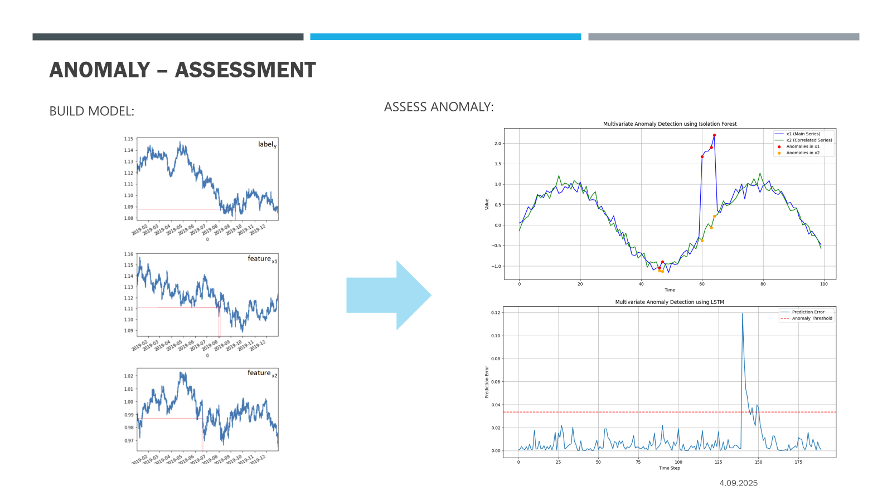

This helps in **fraud detection, system monitoring, and data integrity**—turning data into insight, and insight into impact.

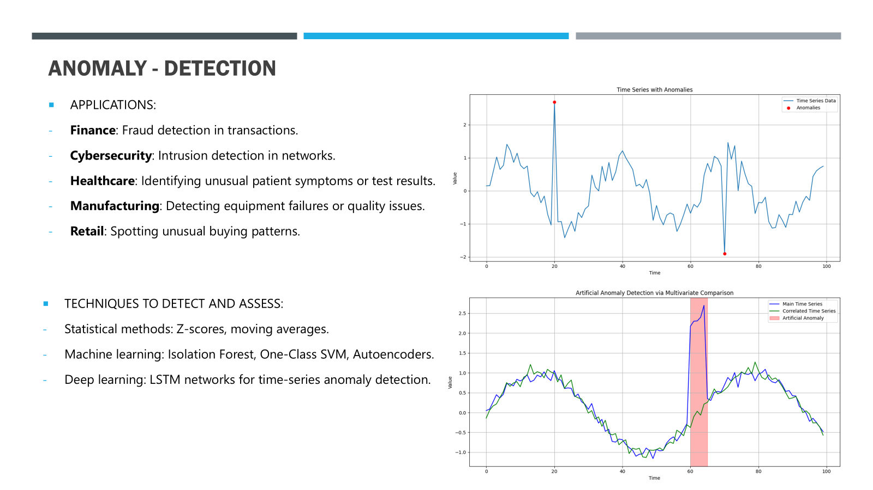

### [AI in Software Development]

AI is also reshaping software development. If you're using **Coding Assistants** to automate repetitive tasks, and next, as a follow up, if you are exploring **Virtual Developers** to manage entire ticket lifecycles, and finally, if you are considering **Agentic Teams** where multiple AI agents collaborate to ship projects—are you really confident in your ability to ensure quality, maintain trust, and scale safely?

### [PwC’s Agentic Development Solutions]

We help clients navigate this shift with solutions like:

* **SDLC Canvas** – AI translates business goals into features and test cases.
* **RapidCraft** – AI turns text into UI components and production-ready code.
* **Code Intelligence** – AI analyses large codebases, automating documentation, unit testing, and legacy code refactoring.

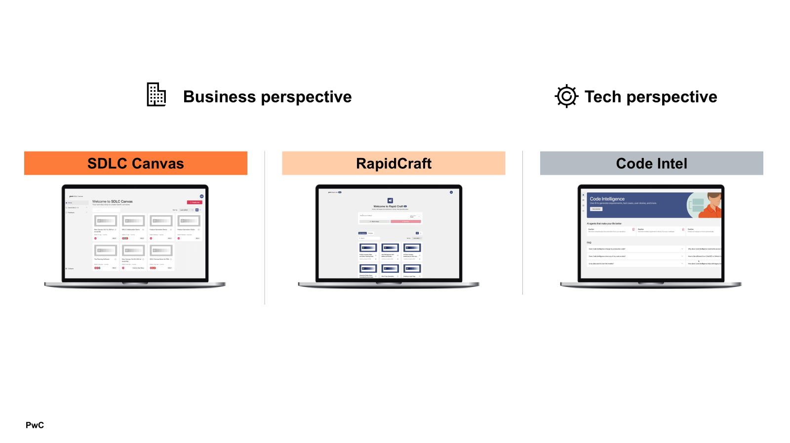

These tools are in use today—**accelerating delivery and improving accuracy**.

### [The Foundation: Data Strategy & Governance]

But none of this works without clean, well-structured, and trustworthy data.

To harness AI for business value, we must:

* Define data ownership and stewardship
* Ensure data quality and accessibility
* Build platforms that support experimentation and scale

(and finally)

* Embed governance and compliance at every layer

### [Cloud Platforms as Enablers]

And this is where **cloud platforms** are strategic enablers of this foundation, and the major cloud providers support this journey:

* Microsoft (with Azure Machine Learning and Azure AI Foundry), Google (with Vertex AI and BigQuery ML), and Amazon (with SageMaker and Bedrock) each offer robust platforms that combine scalable storage, unified analytics, governance capabilities, and enterprise-grade AI/ML development tools.



* These help us **ingest, unify, govern, and deploy AI securely and consistently.**

### [Closing: The Takeaway]

So, what’s the takeaway?

**AI doesn’t start with algorithms—it starts with data**. And with the right strategy, governance, and cloud infrastructure, we can turn data into a strategic asset—fuelling innovation, driving efficiency, and unlocking new opportunities.

**---- [LONG VERSION: 10m] ----**

[Opening: Set the Stage]

Hello, everyone,

Let me start with a simple truth: **AI is only as powerful as the data it learns from**. And yet, many organizations still struggle to unlock its full potential—not because they lack ambition, but because they lack the right foundations.

We’re all chasing innovation—predictive maintenance, intelligent automation, cybersecurity, generative AI. But innovation without impact is just a noise. And impact requires something deeper: **a solid data strategy and governance framework**.

[Introduce Yourself with Purpose]

I’m Wojciech Pazdzierkiewicz. Over the past 20 years, I’ve worked across Security, Identity & Access Management, and IT Infrastructure. For the last decade, I’ve focused on building **complex Digital Cloud Data Platforms**—the kind that power real-world AI and machine learning solutions.

And if there’s one thing I’ve learned, it’s this: **without the right cloud infrastructure and governance, AI becomes a persistent challenge instead of a transformative force**.

[The R&D Mindset: Innovation with Intent]

At PwC, we don’t treat R&D as a department—it’s a mindset. It’s how we explore emerging technologies, solve complex problems, and stay ahead in a rapidly evolving digital landscape.

Let me share a story that brings this to life.

[Story: Intelligent Time Series Analysis]

We recently worked on a project focused on **Intelligent Time Series Analysis**—detecting anomalies and recognizing artificially generated data.

Using deep learning models like LSTM networks, autoencoders, and isolation algorithms, we analysed multivariate time series data to uncover subtle deviations—signals that traditional methods often miss.



Why does this matter?

* In **system monitoring**, it helps us catch failures before they happen.
* In **fraud detection**, it helps us spot synthetic or manipulated data.
* In **data integrity**, it helps us build trust in AI-generated outputs.



This is just one example of how we turn data into insight—and insight into impact.

[The Shift in Software Development]

Now let’s talk about something many of you are already experiencing: **the transformation of software development through AI**.

Across our Cloud & Digital teams, we’re not just experimenting with AI—we’re embedding it deeply into the **Software Development Lifecycle (SDLC)**. And this shift brings both **opportunity and complexity**.

* If you’re using **Coding Assistants**, you’ve seen how AI handles repetitive tasks—scaffolding, test creation, boilerplate code.
* And next, as a follow up, if you’re exploring **Virtual Developers**, you’ve watched AI agents take on entire tickets—writing code, running pipelines, opening pull requests.
* And finally, if you’re considering **Agentic Teams**, you’re entering a world where multiple AI agents collaborate, coordinate, and ship projects—with human oversight.

Exciting? Absolutely. But it also raises questions: **How do we ensure quality? How do we maintain trust? How do we scale safely?**

[PwC’s Solutions: Agentic Software Development]

At PwC, we’re helping clients navigate this shift with a suite of solutions designed for **Agentic Software Development**:

* **SDLC Canvas**: AI translates business goals into features, user stories, and test cases—automating planning and improving consistency.
* **RapidCraft**: AI turns text into UI components and production-ready code—accelerating design workflows.
* **Code Intelligence**: AI analyzes large codebases—automating documentation, unit testing, and legacy code refactoring.



These aren’t just concepts—they’re in use today. And the results? **Faster delivery, improved accuracy, and a more efficient development lifecycle.**

[The Foundation: Data Strategy & Governance]

But none of this works without **clean, well-structured, and trustworthy data**.

To truly harness AI for business value, we must start with data. That means:

* Defining clear **data ownership and stewardship**
* Ensuring **data quality, lineage, and accessibility**
* Building platforms that support **experimentation and scale**

(and finally)

* Embedding **governance and compliance** into every layer of the data stack

And this is where **cloud platforms** play a critical role.

[Cloud Platforms as Strategic Enablers]

Let’s look at how the major cloud providers support this journey:

**Microsoft**

* *Azure Machine Learning:* End-to-end ML lifecycle management—data prep, training, deployment, and MLOps.
* *Azure AI Foundry*: Unified platform for building agentic AI applications.

**Google Cloud Platform (GCP)**

* *Vertex AI*: Unified platform for ML model development, training, and MLOps.
* *BigQuery ML*: Build ML models directly in BigQuery using SQL.

**Amazon Web Services (AWS)**

* *SageMaker*: Comprehensive ML platform for building, training, and deploying models.
* *Bedrock*: Managed service for generative AI with access to foundation models (Anthropic, Meta, Cohere).



These aren’t just tools—they’re **strategic enablers**. They help us:

* Ingest and unify data from diverse sources
* Ensure data quality and governance
* Enable scalable analytics and experimentation

(and finally)

* Deploy AI models securely and consistently

[Closing: The Takeaway]

So, what’s the takeaway?

**AI doesn’t start with algorithms—it starts with data.**

And with the right strategy, governance, and cloud infrastructure, we can turn data into a strategic asset—fueling innovation, driving efficiency, and unlocking new opportunities.

**5.9**

**Preparing the Soil for AI to Bloom: Why People and Data Matter**

Hi, cześć, I’m Natalia Roślik, and I’ve been working in the data field for almost 15 years, growing from an intern to a manager and project leader. Despite a busy work life managing complex data projects, my great passion has always been flowers and gardening.

So, let me ask you a simple question:

How do you grow a beautiful garden?

You don’t just spread seeds and hope for the best. You prepare the soil, water the plants, and care for them every day. Without this care, even the best seeds won’t bloom.

Data in your company is like those seeds. AI is like the garden that can grow from them – full of potential, but only if the soil is right.

That soil is your Data Strategy and Governance.

Without a strong foundation – meaning clean, trusted data, clear roles, and ethical guidelines – AI won’t grow well. It will struggle, deliver poor results, and your investment won’t bloom.

But here’s the key – technology alone is never enough.

People are the gardeners. Your teams need to understand, support, and guide AI with constant care and curiosity.

AI isn’t plug-and-play. It’s a process of learning, testing, and refining – like tending your flowers every day to help them grow stronger and more beautiful.

At PwC, we combine this human approach with proven data strategies. We help you prepare the soil, plant the right seeds, and support your people – so your AI garden delivers real business value.

If you want your AI to truly bloom and drive growth, the question isn’t just “What technology should we use?”

The question is – “How will we prepare our people and data to make AI grow?”

Let us help you make that happen.

# Section 6: A word of caution

* 1. Big bang approach vs incremental development i.e. revolution vs evolution
  2. Customisation vs off-the-shelf solutions
  3. Neglecting change management
  4. Ignoring common pitfalls when experimenting with AI

# Section 7: Taking the first step

**Paweł Fiderek:**

Taking the first step in transforming into a data-driven organization involves a structured approach that sets the foundation for leveraging data effectively across the business. Here’s an outline of the process:

**1. Define a Clear Vision and Objectives**

**What to do:** Leadership should articulate why becoming data-driven matters for the organization and what specific business goals this transformation will support.

**Why it’s important:** A clear vision aligns stakeholders and provides direction for all data initiatives.

**2. Assess Current State and Capabilities**

**What to do:** Conduct an audit of existing data assets, infrastructure, tools, processes, and skills. Identify gaps in technology, data quality, and analytics capabilities.

**Why it’s important:** Understanding where you stand helps prioritize efforts and allocate resources wisely.

**3. Identify High-Impact Use Cases**

**What to do:** Select initial projects or business problems that can benefit most from data-driven solutions and deliver measurable value quickly. These should be achievable and aligned with business priorities.

**Why it’s important:** Early wins build momentum, demonstrate value, and encourage broader adoption.

**4. Establish Governance and Data Quality Standards**

**What to do:** Define policies for data ownership, access, privacy, and security. Put in place processes to ensure accuracy, consistency, and reliability of data.

**Why it’s important:** Good governance is critical to trust in data and compliant, sustainable operations.

**5. Build the Right Team**

**What to do:** Assemble a cross-functional team combining domain experts, data scientists, analysts, and technologists. This team drives the initial projects and fosters a culture of collaboration.

**Why it’s important:** Diverse skills and perspectives enhance problem-solving and knowledge sharing.

**6. Choose the Appropriate Technology Stack**

**What to do:** Select tools and platforms (data warehouses, BI tools, machine learning frameworks) that fit your needs and scales. Consider cloud solutions for flexibility.

**Why it’s important:** The right technology enables efficient data processing, analysis, and visualization.

**7. Pilot Projects and Iterate**

**What to do:** Launch pilot initiatives focusing on selected use cases, gather results, learn from outcomes, and refine approaches.

**Why it’s important:** Iterative learning mitigates risks and improves solution effectiveness.

**8. Promote a Data-Driven Culture**

**What to do:** Encourage data literacy through training, workshops, and inclusive communication. Recognize and reward data-driven decision making at all levels.

**Why it’s important:** Culture change ensures long-term adoption and maximizes return on investment.

* 1. Start with a strategic review
  2. Identify pockets of value and estimate return on investment
  3. Secure c-suite support and business sponsorship
  4. Adopt Data Governance best practices
  5. Build a prototype and establish proof of concept

# Section 8: Client feedback / testemonies / case studies based on previous projects

Teasers on linkedin shorts

So we do DG etc. for client to focus on business value

Including partners

# Authors & Contributors

Pawel Kaczmarek

Director

Cloud & Digital

PwC Central & Eastern Europe

Marek Chlebicki

Partner

Advisory

PwC Central & Eastern Europe

Wiktor Witkowski

Senior Manager

Advisory

PwC Central & Eastern Europe

Mariusz Strzelecki

Senior Manager

Advisory

PwC Central & Eastern Europe

Adam Rogalewicz

Partner

Advisory

PwC Central & Eastern Europe

Pawel Wrona

Partner

Advisory

PwC Central & Eastern Europe

Michael Norejko

Senior Manager

Cloud & Digital

PwC Central & Eastern Europe

Co-authors

Pawel

Daniel

…